**AI Smart Weapon Detection**

Final Year Project Proposal

(BSCS)

By

|  |  |  |  |  |
| --- | --- | --- | --- | --- |
| S# | **Name** | **Registration #/Roll #/Section** | **Mobile #** | **E-Mail** |
| 1. | Saad Amir | Fa-2021/051/B | 0305-5007687 | saad.amir@live.com |
| 2. | Nawab Iftikhar | Fa-2021/076/B | 0333-1474584 | nawabpanu@gmail.com |

**Supervised by:**

Ma’am Anila Amjad **___________________ (**Signature**)**



Department of Computer Science

Lahore Garrison University

Lahore

**Abstract**

Security and surveillance systems play a critical role in ensuring public safety and safeguard assets around the word, but these systems are often challenged by the overwhelming amount of data which they have to monitor and analyze . There is very little margin of error in this project keeping that in mind initially we are planning to build similar system for a tiny firm for testing purposes . If we succeed in this than we will focus on something big .This project proposes the development of an intelligent system which tends to reduce the workload on surveillance and security department by accurately predicting and reporting suspicious or malicious activities in real time.

The program is comprised of advanced technologies including **artificial intelligence** (**AI**)**,** **machine learning** (**ML**)**,** **computer vision,** **data mining,** **digital image processing,** **feature engineering** to analyze patterns, detect anomalies and anticipate potential threats. By integrating these technologies the system can process vast amount of data from various sources such as camera , sensors to report any unusual activity taking place at that moment of time. This proactive approach allows security personnel to focus on genuine threats while reducing false alarms and enhancing situational awareness.

**Introduction**

In today’s modern world, safety and security is a big concern, cameras to some extent assist in this regard but that requires a person who monitor it almost all the time. What if we don’t have to do any hustle just one time installation and we would get all the potential threat warnings on our smart devices or sent directly to security department depending on you, with rising crime rates there must be a solution to this problem and that’s where this project helps, it does this by analyzing people’s behavior in proposed places where security is of key importance and if they do anything suspicious or are in danger or in need of help the program informs the appropriate authorities.

**Problem statement**

* The problem of increasing crime rates is at an all time high especially in developing countries, there is an urgent need of a solution.
* People’s assets are at risk of being stolen.

**Project scope**

* This project aims to help in this regard by increasing the efficiency of surveillance system and security systems. Banks and other places where security is needed the most will benefit greatly from an AI model that will automatically trigger the alarm in case of a security breach. The system would alleviate a lot of man power as there would not be a need for people to sit on cameras instead the system will give an alert depending on the situation it analyzes and inform the appropriate authorities.
* This project will aid in reducing robberies by accurately reporting the results of a tense situation to the concerned authorities, the model will be made as light as possible so that it does not have any hardware bottlenecks and will be able to work on any computer with access to a camera, where the camera will provide the model with input and it will inform about any unusual activity.
* For organizations that prioritize security a program like this will prove to be quite beneficial because of its accuracy.

**Proposed Project development methodology**

The project is based on a plethora of concepts such as computer vision, machine learning, deep learning, digital image processing, transfer learning, web scraping, data mining, feature engineering, we will use these technologies in synchronous harmony such that the image/video acquired from the camera undergoes through multiple color transformation. i.e. RGB to gray scale using digital image processing techniques is then forwarded towards the ML/DL model that was trained on an immense dataset which was acquired using popular data providing websites but the process of getting the data was difficult and time consuming so we utilized the techniques of data mining and web scraping, this does not mean in any way that we used unethical ways to acquire the data, we just used automated web scraping bots to acquire the data from public websites, this hard acquired data will then be engineered into features that our model can use and be trained upon, after training the model will be evaluated.

**Tools:**

* Python
* opencv
* pytorch
* tensorflow
* numpy
* sklearn
* selenium
* beautifulsoup (BS4)
* Scrapy

**Flowchart:**

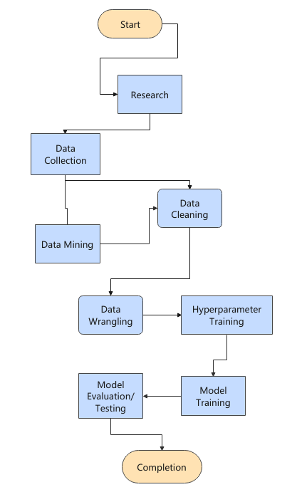

**Project milestones and deliverables**

* **Milestone 1:** Gathering Data (Month 1)
* **Milestone 2:** Data Wrangling and Preprocessing (Month 2)
* **Milestone 3:** Hyper parameter Tuning(Month 3-4)
* **Milestone 4:** Model Training (Month 5)
* **Milestone 5:** Model Evaluation and Testing (Month 6)
* **Milestone 6:** Completion

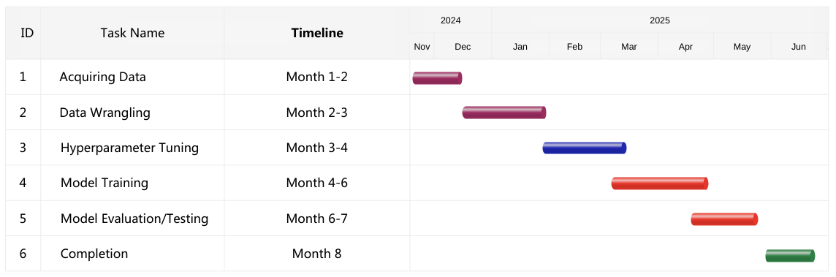

**Literature Review**

Here are the list of publications that we take inspiration from:

* https://viso.ai/applications/computer-vision-in-smart-city-applications/
* <https://viso.ai/applications/computer-vision-applications-in-surveillance-and-security/>
* https://medium.com/analytics-vidhya/theft-detection-using-machine-learning-a4232ea51f1c/